## INSTALLATION AND WIRING INSTRUCTIONS

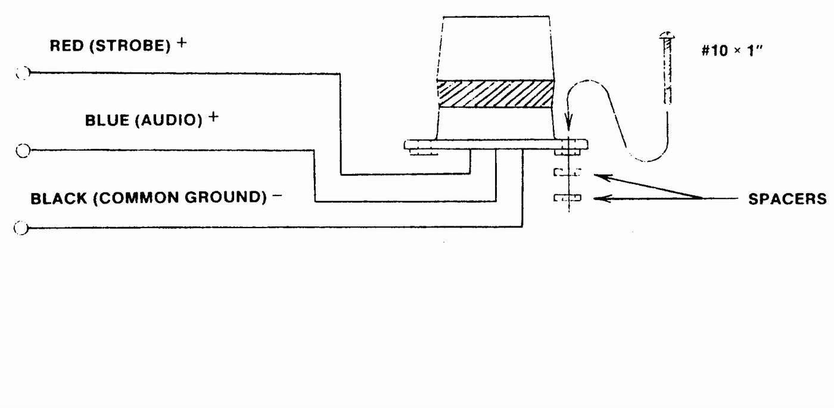

**Models AV4012 (12Vdc) & AV4024 (24Vdc)**

1. Mount Strobe unit using the four (4) sheet metal screws and plastic washers included. Note***: For optimum sound, mount strobe unit on plastic spacers provided as shown in above diagram.***
2. Connect black wire (common ground) to the negative terminal of power source.
3. Connect red wire to positive terminal of power source.
4. Connect blue wire (audio) to positive terminal of power source.

***Note: Audible portion of Strobe can be interfaced into switching devices.***

**SERVICE AND REPAIR:**

Should the light fail to operate, check to see that the proper voltage and polarity is reaching the unit. If the unit still fails to operate, return unit to the manufacturer for test and repair as required. The Light/Sound Safti-Strobe is of modular solid-state construction, utilizing the highest quality of components available; therefore, no field repairs other than lens replacement are recommended.

**WARNING: High Voltage is present in this unit. Refer to authorized personnel for repair.**

**Caution: When it becomes necessary to enter circuit chamber, wait five (5) minutes after disconnecting power before opening unit, to allow capacitors time to discharge.**